**Introduction:**

**Background and Business Problem**

Payroll taxes are those taxes paid by employees and employers through the payroll process. That is, the employer withholds these taxes from the employee pay, and remits them on behalf of employees and themselves to the appropriate taxing agencies.

U.S. Payroll taxes include a few components:

**Federal Income Tax Withholding**: [These are taxes withheld](https://www.thebalancesmb.com/what-wages-are-used-to-calculate-withholding-398706) from employee pay for federal income taxes owed by the employees. The amount of federal income tax is determined by information employees provide on the [Form W-4](https://www.thebalancesmb.com/form-w-4-information-for-employers-398524)they complete when hired. This form can be changed by the employee at any time and as often as the employee wishes.

**Taxes Paid for Social Security and Medicare (**[**FICA taxes):**](https://www.thebalancesmb.com/fica-taxes-social-security-and-medicare-taxes-398257)FICA stands for Federal Insurance Contributions Act. Employees and employers share the responsibility for these taxes, with the employer deducting the employee's share (one-half of the total due) from employee wages, and paying the other half.

Payroll taxes also include amounts payable by businesses for FICA tax, which are equal to the amounts paid by employees. An employer calculates the gross pay for an employee, then, based on the employee's gross pay:

- Deducts a specific amount for federal income tax, based on the W-4 form the employee has completed most recently, and

- Deducts a specific amount for FICA taxes.

**State Income Tax Withholdings:** Similarly to the federal taxes, some but not all states also cumulatively deduct a portion of salary to account for state taxes that will be owed to the IRS at the end of that tax year. This rate is different for all states.

**Employer Contributions:** Apart from employee deductions, and the FICA employer portion, employers also contribute to the Federal Unemployment Tax Act (FUTA) payment for the employee. This amount does not factor into the employee net pay, and is a based on a percentage of each employee’s salary up to USD 7,000 for the year. There is also a state version of this contribution, (SUTA) that differs by state, and also doesn’t affect the net pay amount of the employee.

In America, every paycheck an employee receives is subject to payroll taxes. Off of any certain amount of salary, the employee’s paycheck will show how much he or she takes home each month, what the employee owes in deductions, and the amount of additional payroll taxes the employer has to contribute on top of the salary.

It is hard for the employee to get the best estimate of the net pay amount, and how the employer contributes for his or her payroll taxes. Majority of today’s tax applications are for the employer to run the payroll, but very rarely will there be an application for the employee to figure out his or her portion of the payroll taxes, or what the employer contribution to the employee’s tax paying is. There are also employees who work in multiple states throughout the calendar year. The estimation of payroll taxes for such individuals is even harder. For professionals such as accountants, an employee may be required to travel to different cities and states to work with a client. For these reasons, we are confident that there is a good market need for this functionality for individuals who like to plan ahead, and understand their paycheck breakdown.

**Project Scope**

We employed the following guidelines to define the scope of the application for the target user and functionality:

* The system will only accept up to three states entered; and only the states of Arizona, Utah, and/or Nevada.
* The application is limited to users who for tax purposes, are considered residents. This includes U.S. citizens, permanent residents, green card holders, and any legal alien resident who has filed taxes for five years as a non-resident already. The last group’s qualification changes once they cross the five year mark.
* In order to tailor the output for that employee, there will be employee information fields where they would input data. We ask the user to enter their name if they make a profile. We also limit the user to one profile, and for security purposes, guest users enter their names as optional entries.
* To maintain user security, no data entered for runs can be retrieved later allowing for no user data retention. All users can however get a screenshot download of the summary page.
* There are a lot of tax rules and regulations in America, making for many scenarios and tax calculations based on the user. With compensation specifically, our application can only accept hourly or annual salary rates. The application will ask the user what rate they are entering. If they select annual, they can input the annual salary. Should they select hourly, they will be prompted to enter both the rate of pay, and hours worked per pay period.
* The software application will be limited to users whose annual gross salary does not exceed USD 100,000. To manage this situation, if the user enters a salary greater than USD 100,000 per year, they will be prompted to adjust the input, or be advised that this application cannot support their need and that they should contact an accountant for further assistance. The users are also informed of this fact on the home page, where they know before hand, and can decide if they want to proceed with using our application.
* Based on Form W-4 allowances, in order to highlight functionality, we will restrict this application and set a floor and ceiling of 0 and10 respectively, for the number of allowances claimed. Again, if the user enters invalid data, they will be prompted to re-enter a valid amount.
* Items like voluntary health insurance, gym memberships, and 401K contributions and matches, will be excluded. As mentioned before, we are focusing on the base U.S. payroll earnings, deductions, and withholdings that appear on all employees’ paychecks. The user will get a calculation based on consideration of federal and state income and social taxes only. Employer contributions will be displayed for informational value so the employee is aware of what their employer adds for their contributions.
* Earnings will be limited to salary only. Bonuses, vacation pay, equity etc. will not be accounted for to keep a standard set of calculations and inputs for the user.
* User will only be able to go back and update the profile data while running a calculation. Once they leave the salary and allowance entry page, they cannot change these values. To make sure this is clear, we have a prompt that lets the user know to review the information before they continue. While navigating back to the profile page, the user will be able to change specific inputs to fit their needs e.g. between marital status, number of states entered.
* There will be an admin user of the application who is able to update the tax rates and the information that appears in the contact, news, and help and information sections. Additionally, an admin user can delete feedback provided by users from the database after it has been reviewed.

**Business Value**

Tax calculations are always a complicated task for working individuals. This application will help an employee to have better understanding of his/her payroll taxes and analyze a good estimate for their net pay. An understanding of payroll taxes calculation will ensure the employee that the proper amounts have been deducted from their paychecks. The application will give an employee a summary page which includes the gross pay for that period, payments they owe for the pay period and payroll taxes contributed by their employer. Another added value for the employee is that because they can anticipate their paycheck, it is easier to plan for any changes they may be experiencing. This would allow them to change the allowances claimed on the Form W-4, have better budgeting tools, and be a second check for their payroll department in case of any errors.

**Application Flow:**

In preparing our application flow, we came up with a list of forms that would each contain functions to fulfill the scope and user requirements. The table below shows the list of forms that will be employed.

|  |  |  |  |
| --- | --- | --- | --- |
| **Home** | **Help & Information Tab** | **My Account Tab** | **Payroll Tax Application** |
| (one form with multiple tabs:  - About Us & News and Updates – includes link to each tab below:  - Help and Information  - Contact Us (includes contact information, feedback form, and a link to the help and information page)  - My Account tab | (tab in the main form)  - IRS Payroll Tax Info  - Tax policy updates  - Helpful Links for knowing about tax calculations | (tab in the main form)  - Return User / Log In (includes Admin Log In)  - New User / Sign Up  - Visit as Guest  - Admin User (tax rates, home page, contact information, manage user feedback) | (one form with multiple sections:  - Employee Info Input  - Payroll Info Input  - Employee Deductions and Withholdings  - Employer Contributions  - Take Home Net Pay  - Review Page – (Export/Save options)  - Redirects to home page after completing calculation |

As the table above displays, the application is composed of five core modules (one form with four tabs, and the admin section). These include: *Home, Help & Information, My Account, Payroll Tax Application*, and *Admin Functions*. Each of these modules has multiple sections or links for selection by the user.

**Functions on Each Form**

1. **Home**

This is the general main page for the application. It provides users a GUI to look at the general structure of application, and shows them the right place to click for information or action. We include four functions (subpages) under this module:

* *About Us:* list the application background and developer’s story, target market of the application, and some links to navigate through the application.
* *Tax Policy Updates:* This section shows tax news or regulations that have been updated; serving as a tax news posting board by the admin user.
* *Contact Us:* This tab in the main form is where we provide the user with contact information for our design team. Additionally, there is a feedback form where they can ask questions and give suggestions. These comments are managed by the admin user and can be deleted once addressed.

1. **Help & Information**

* *IRS Payroll Tax Info:* lists useful links from the IRS which help define and explain W-4 allowances, FICA, FUTA, Medicare, and SUTA. etc.
* *Helpful Information:* We added a section with articles that give the user some insight on tax definitions, tax regulations in the states that the application works with, and some general multistate tax calculation information.

*Time Constraint Omission:* Frequent Asked Questions. Due to time constraints, this will only be completed if we have achieved the main requirements of the application before its deadline. The above note still stands. We were not able to add this feature to the application.

1. **My Account**

* *New User:* Link to a Sign Up page
* *Return User:* Link to the Payroll Tax Application profile confirmation page (the user’s data will be retrieved at to display from the database). This user’s data can also be saved after a calculation. Currently a limitation of our application is that we cannot check for email verification. This would be a future enhancement.
* *Admin Login:* Link to update help and information links, home page links, tax rates, and database tables. This user does not need access to computing a calculation on the payroll tax application. They also log in the same way as a returning user, but based on their user ID, they are redirected to the updates section.
* *Use as Guest:* Link to Payroll Tax (the user’s data will not be saved after the application closes).

1. **Payroll Tax Application**

This is the core module of the website. The user will input or update all the data needed to generate the payroll tax calculations. We divide the input and output into three sections and pages. The profile, tax calculation, and review pages will have five sections for input and output as follows:

* *Employee Data and Location Input:* the user will input personal data in the section including: Name, *Marital Status, and *State(s) of employment to file Tax. The items with an asterisk are all mandatory input values. Member users will see this portion as needed since this information is retrieved from their profile.
  + *Payroll Info Input:* the user will input the amounts they earn, and allowances claimed, including: Wage Amount per Pay Period (period options listed for user’s selection: hourly and yearly), Form W-4 Allowances Claimed (user has the option to select up to 10 allowances), and the duration worked in a specific state. All items on this page are mandatory inputs.

The second page which contains the export product, will show the user a contingency table with the above output sections, and give them the option to download or save depending on whether or not they are a member. This page will have the following items displayed in the three categories named below:

* *Employee Deductions and Withholdings:* there are five outputs on employee side in the section including; Federal Insurance Contributions Act (FICA)-Employee for Social Security, FICA Medicare Tax-Employee, Federal Withholdings-Employee, and State Withholdings-Employee (if applicable – NV does not have state withholding).
* *Employer Contributions:* there are four outputs on employer side including; Federal Insurance Contributions Act (FICA)-Employer for Social Security, FICA Medicare Tax-Employer, Federal Unemployment Tax Act (FUTA) -Employer, and State Unemployment Tax Act (SUTA)-Employer. These do not affect the bottom line of an employee’s paycheck, but are good informational inclusions to make the employee aware of amount paid on their behalf by their employer.
* *Base Compensation:* This section shows the employee’s salary before (gross pay) and after (net pay/take home) taxes. This section and the employee deductions and withholdings section are related in that the net pay is the difference between gross pay and federal and state deductions and withholdings.

All output categories above are displayed in three sections – total amounts which are based on the duration of work of the employee, along with a monthly and bi-weekly breakdown.

1. **Administrator Updates**

In this section, the administrative user updates to the tax rates, the site navigation pages, and manages customer feedback by reviewing, and deleting it when needed.

* *Tax Updates:* includes tax rates for federal categories, the federal tax withholding tables, state withholding and unemployment rates.
* *Site Navigation Pages:* The admin user can also update the about us section, the news, help and IRS links, and the contact information for main form tabs.
* *Feedback Table:* The user feedback that is sent to our team can be managed and reviewed by the admin user. Once this information is reviewed, it can be deleted.

**Interface:**

For our interface, we have formed a website with pages that the user can navigate while using the payroll tax application.

These pages serve different functions such as news and tax information for the user, instructions on how to use the application, contact information, and the application itself. All together, the user is able to navigate through four pages seen below:

When the user goes to our site, they will land on the **home page** which shows them some news and tax updates, information about the application development company, and a link to the help and information, my account, and contact us pages.

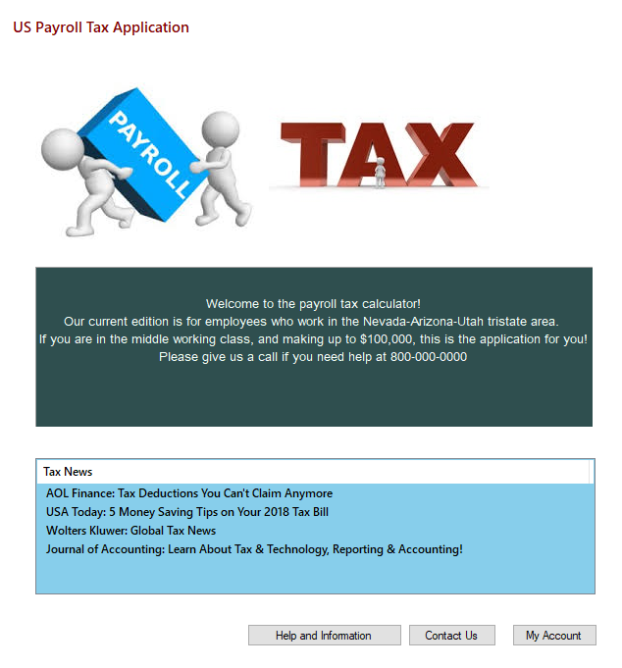

On the **help and information page**, the user can see some links to IRS pages for several definitions of the input values e.g. W-4 allowances, a general IRS link to definitions of all categories and inputs, etc. On this page, the user will also have the option to continue onto log in or use the payroll tax application as a guest.

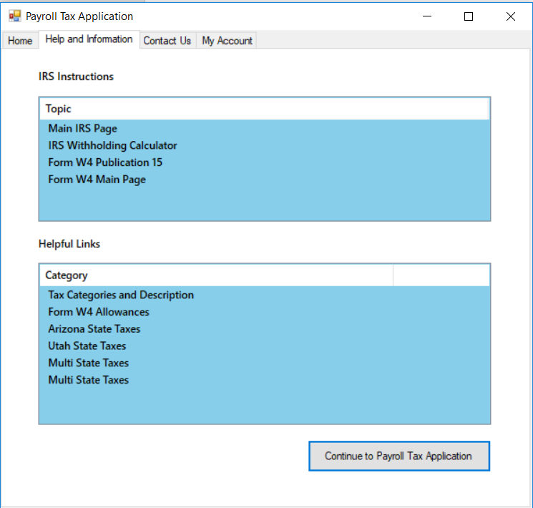

Another page that the user can navigate to from the front page is the contact us page where they are able to see how to reach the site creators, and provide feedback and any questions they have.

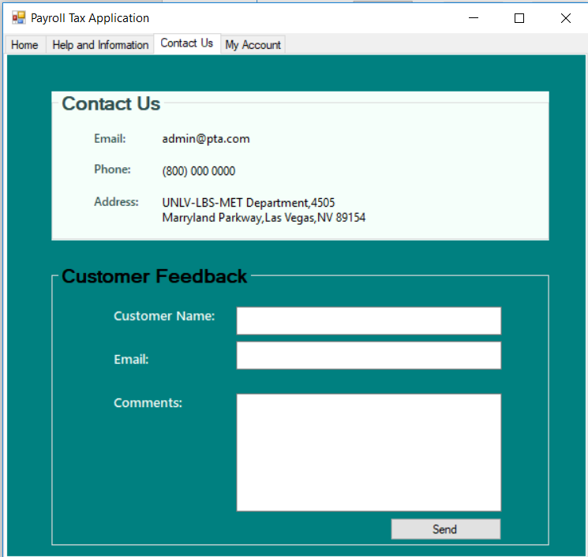

Lastly, from both the home and help pages, a user can navigate to the **“My Account”** page where they can log in, or continue to use the application as a guest. Both pages will redirect the user to the payroll tax application. If they select “Sign Up” the system will direct them to a page where they enter employment, and marital status information as seen below:

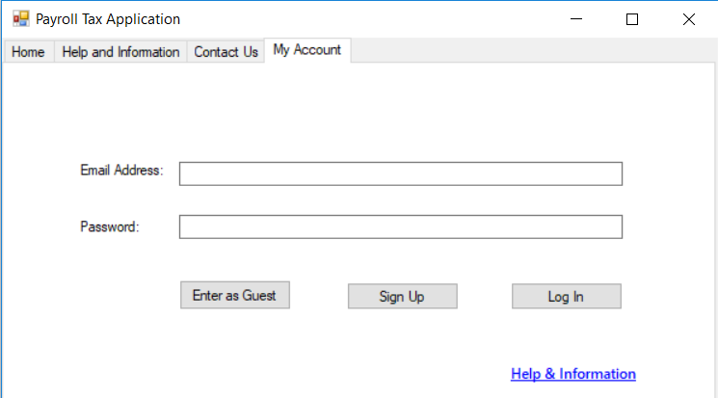 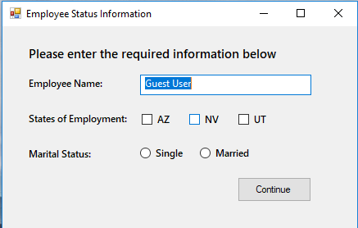

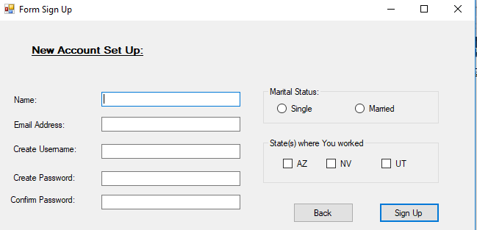

Additionally, an administrative user can also log in to the site to update several pages and information stored in the database. This type of user doesn’t need to sign up for an account as the credentials will be built into the system when the application is being designed. Once logged in, the admin user can select one of four parts of the site to update, below:

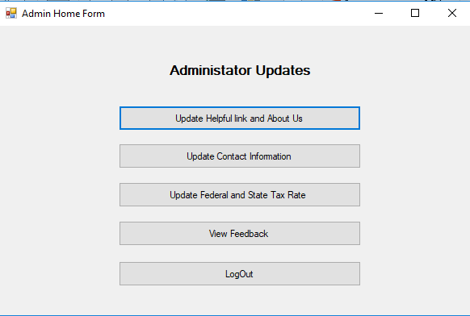 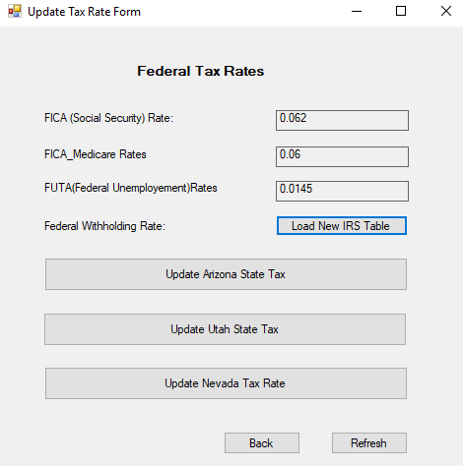

 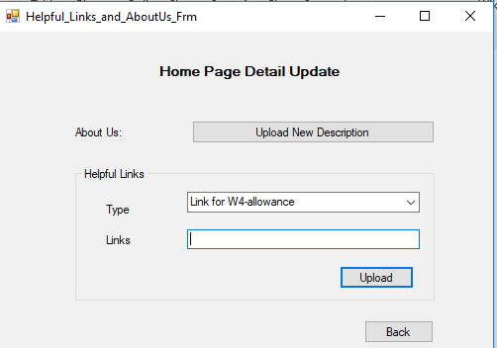

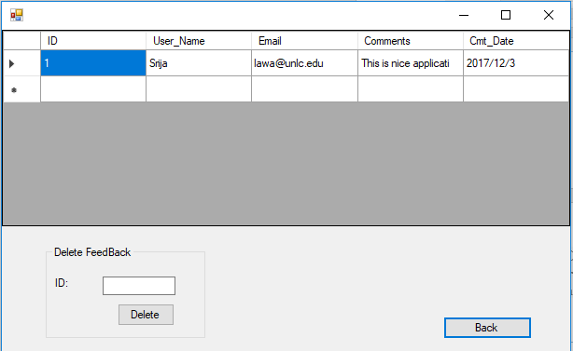

Admin users can also review and manage the user feedback sent as seen above. For the non-admin users, since they are using the application strictly for calculation of payroll taxes, they will see the confirm profile page and get the chance to edit and enter their user data before a calculation runs. Users will only see the tabs for the states that they have checked in the profile page.

 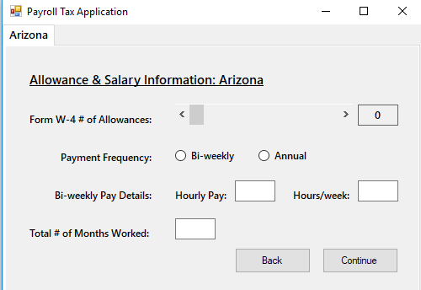

*One limitation* of our application is that for multi-state employees, they have to click the continue button on each tab for an accurate calculation to occur. Future enhancements of this application would include a fix for this tab toggle issue.

Once the information is entered, we follow IRS and state guidelines using percentages for federal unemployment, federal withholdings, social security and Medicare deductions, and state unemployment to calculate the base taxes owed and withheld by an employer. An example of a federal withholding calculation can be found on page 43 of the supporting document ***Publication 15 2017***, provided along with the application materials. We decided to use 2017 guidelines because not all 2018 guidelines have been made available for state taxes. For verification of rates, we worked with a practicing accountant to verify amounts for these values. Additional resources are also available in the text file titled ***Tax Guidelines Supporting Information***.

Once completed, the user is asked to verify entries and are redirected to the **export page** where all users have the option to download the calculations and breakdown as a PDF. *Another limitation* at this stage of our application is the output is not always of best quality. We note this to the user, so that they can take a good screenshot for their records if desired.

Members also get the additional option to save the output to their profile for later use. Therefore, this “save” and “log out” buttons will only be visible to members with profiles on the site. The save function allows us to store this information in the database. A future improvement would allow us to show the user a version history should they want to see this information.

We believe that having this on the application will add value to both the user for questions, and the developers for feedback.

**File and Database Design:**

Our application contains Helpful links, About Us and Contact Information section where we have kept different helpful links, information about the application, and contact information to reach to us. We displayed all this information reading HelpfulLinks.txt, Aboutus.txt, contact.txt files. All the information in these files is written by admin. In this application, we are going to show the pay check and the amounts deducted and contributed for tax along with the gross and net pay after deductions. A user will have the option to download this information, which we will be saving as an image in a PDF file.

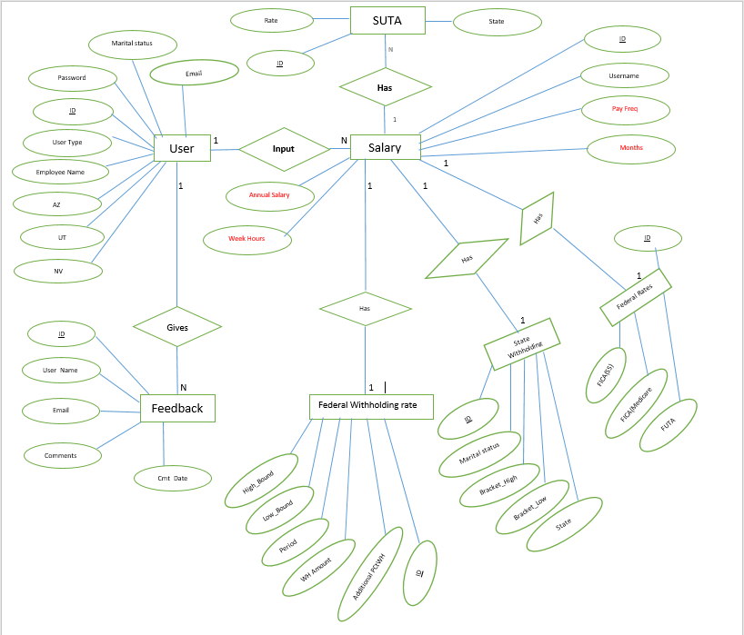

\*\**Fields with red text are ones which are added according to state but because of space constraints, we have mentioned one field to represent the three states*

*Entity Relation Diagram – Payroll Tax Application*

For this application, we created seven tables. The main ones that store user information are the Users, Salary, and Feedback tables. The rest of the tables are used to store tax rates.

If a user chooses to login as a guest then their information will not be stored in database. We have two types of users: The admin user will be maintaining the details of the tax rates and the files to be shown in the application (help and information, contact information, about us description). We also have the normal user, who will be using the application to calculate their payroll taxes.

For this application, we created TaxUsers database with following tables and fields:-

* tblFederalRates
  + Type: Displays the type of Federal rates. Data type : String
  + Rate: Data type: Decimal (Currency has been used because number format rounds decimal values)
* tblFederalWH
  + Marital status: Data type: String
  + Period: Data Type: String
  + Low_Bound: Data Type : Double
  + High_Bound :Data Type : Double
  + WH_Amount: Data Type : Double
  + Additional PctWH: Data Type : Percentage
* tblFeedback
  + User_Name: Data Type : String
  + Email: Data Type : String
  + Comments: Data Type : String
  + Cmt_Date: Data Type : Date
* tblSalary
  + Username: Data Type: String
  + AZPayFreq : Data Type: String
  + AZMonths: Data Type: Decimal
  + AZHourlySalary: Data Type: Decimal
  + AZWeekHours: Data Type: Decimal
  + AZAnnualSalary: Data Type: Decimal
  + NV PayFreq : Data Type: String
  + NVMonths: Data Type: Decimal
  + NVHourlySalary: Data Type: Decimal
  + NVWeekHours: Data Type: Decimal
  + NVAnnualSalary: Data Type: Decimal
  + UTPayFreq : Data Type: String
  + UTMonths: Data Type: Decimal
  + UTHourlySalary: Data Type: Decimal
  + UTWeekHours: Data Type: Decimal
  + UTAnnualSalary: Data Type: Decimal
* tblSalary - continued
  + AZFICA_SS_EE: Data Type: Decimal
  + AZFICA_SS_ER: Data Type: Decimal
  + AZFICA_Medicare_EE: Data Type: Decimal
  + AZFICA_Medicare_ER: Data Type: Decimal
  + AZ_FederalWH: Data Type: Decimal
  + AZ_FUTA: Data Type: Decimal
  + AZ_StateWH: Data Type: Decimal
  + AZ_SUTA: Data Type: Decimal
  + NVFICA_SS_EE: Data Type: Decimal
  + NVFICA_SS_ER: Data Type: Decimal
  + NVFICA_Medicare_EE: Data Type: Decimal
  + NVFICA_Medicare_ER: Data Type: Decimal
  + NV_FederalWH: Data Type: Decimal
  + NV_FUTA: Data Type: Decimal
  + NV_StateWH: Data Type: Decimal
  + NV_SUTA: Data Type: Decimal
  + UTFICA_SS_EE: Data Type: Decimal
  + UTFICA_SS_ER: Data Type: Decimal
  + UTFICA_Medicare_EE: Data Type: Decimal
  + UTFICA_Medicare_ER: Data Type: Decimal
  + UT_Federal_WH: Data Type: Decimal
  + UT_FUTA: Data Type: Decimal
  + UT_StateWH: Data Type: Decimal
  + UT_SUTA: Data Type: Decimal
* tblStateWH
  + State: Data Type: String
  + Marital Status: Data Type: String
  + State WH Rate: Data Type: Decimal
  + Bracket_Low: Data Type: Decimal
  + Bracket_High: Data Type: Decimal
* tblSUTARates
  + State: Data Type: String
  + Rate: Data Type: Decimal
* tblUsers
  + User type : Data Type : Integer where 1 represents normal user and 0 represents admin
  + Username: Data Type: String
  + Password: Data Type : Integer and Length:7
  + Employee Name: Data Type : String
  + AZ: Data Type : Integer where 1 means working in Arizona state and 0 means not working
  + UT: Data Type : Integer where 1 means working in Nevada state and 0 means not working
  + UT: Data Type : Integer where 1 means working in Utah state and 0 means not working

** Every table has ID which is primary Key for every table

As mentioned earlier, if a user chooses to login as guest then their information will not be stored in database.

**Detailed Design:**

With the detail design, we used flowcharts to demonstrate the functions and flow of the different pages on the application site.

**Home Page:** This page will include a short description about the application, a link to the help and information page, and some news and updates that are useful to know for any user of this application. After reading the instructions and looking at the help and information linked page, the user can go to the next page to log into the program.

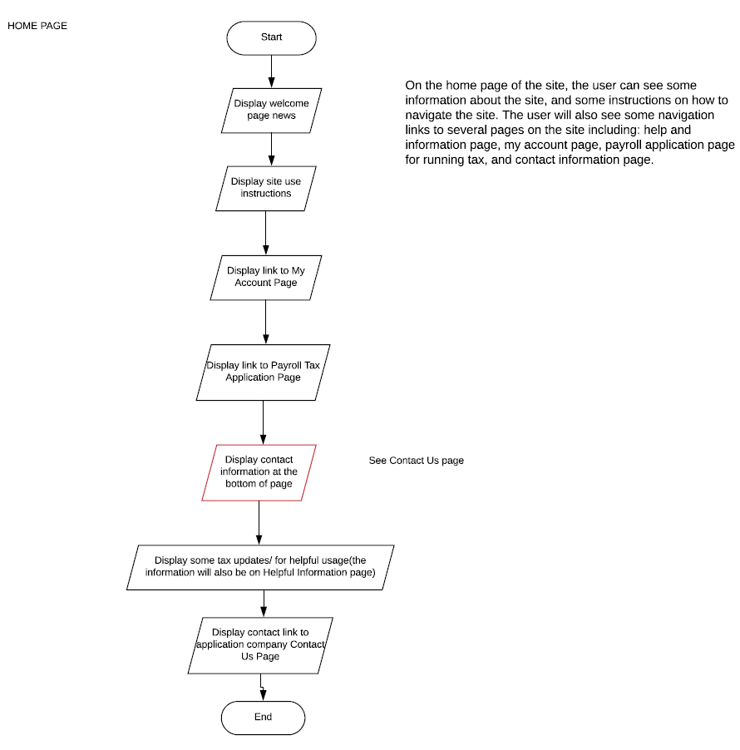

**Helpful Links:** This page has instructions for the user on what to fill in the form and IRS instructions for how to decide W-4 allowances, any tax updates and changes for the current calculation year etc.

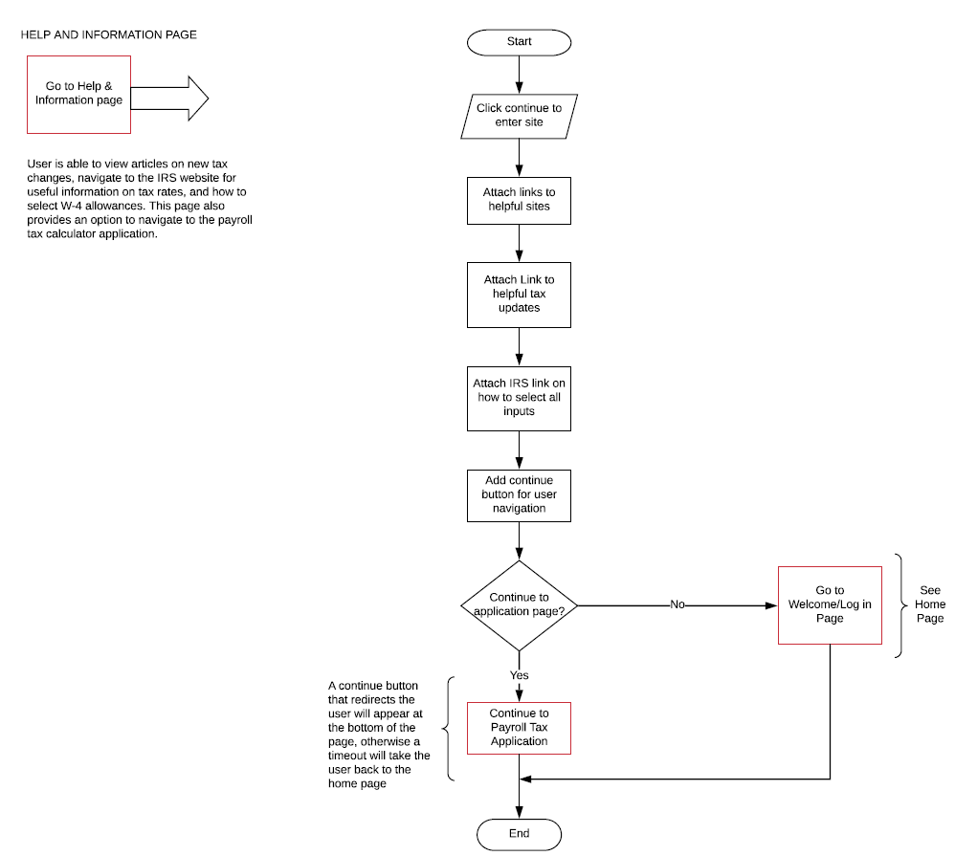

**My Account Pages:** The user will either log in to the application as a returning member, create a new profile and add some information that is used for the tax calculations, or proceed with using the application as a guest. Additionally, an admin user is able to log into the application to update some site information, and the database tables and tax rates.

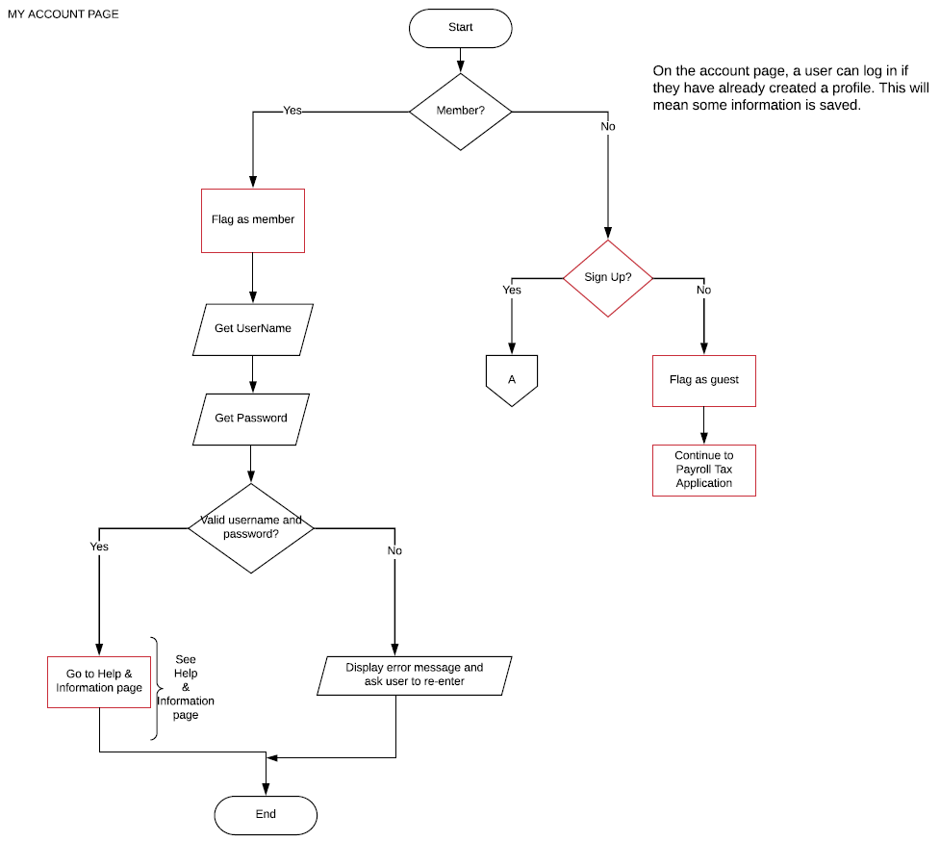

For each step, the username and/or password is checked for validity before access to the application is granted. In the case of the admin user, the access to the update items is also checked with a valid entry of username and password.

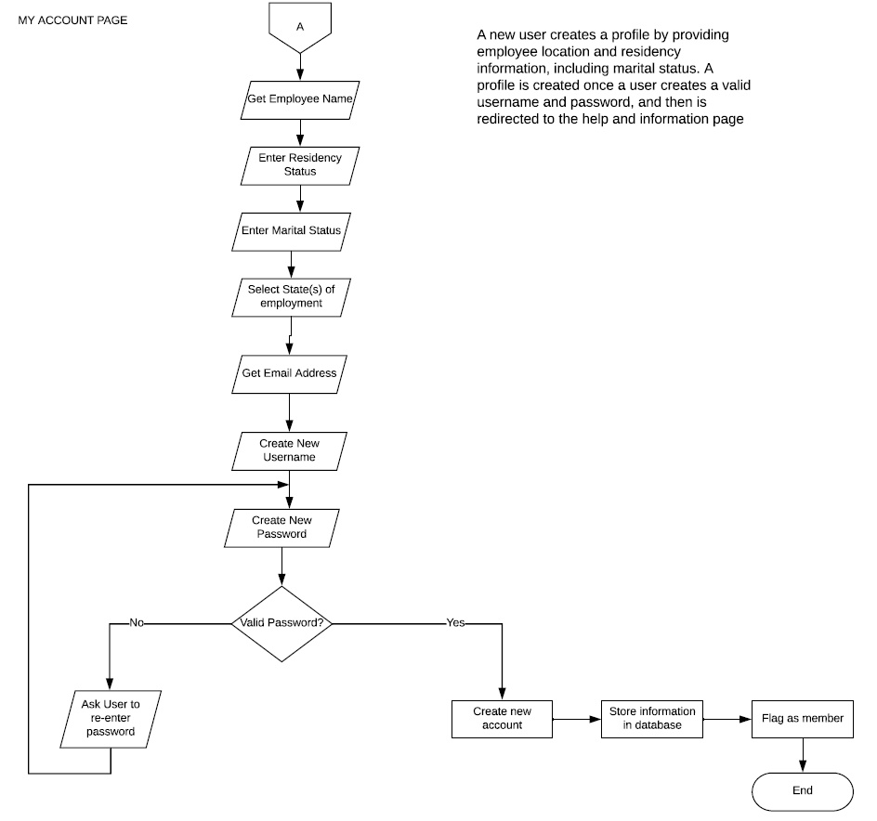

As seen above, a new user who would like to create an account would enter some location, marital status, and residency information before the profile can be saved. This information will be used for the calculation.

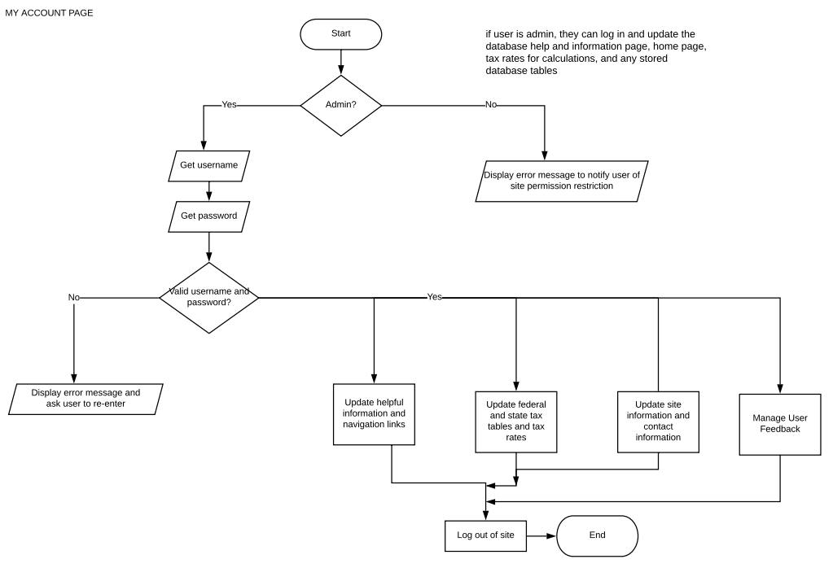

A flowchart for the admin user who works to update site information is seen above. All functions that can be completed once the admin user is logged in are also seen in the flowchart below

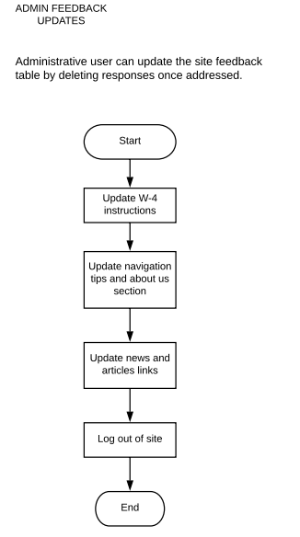

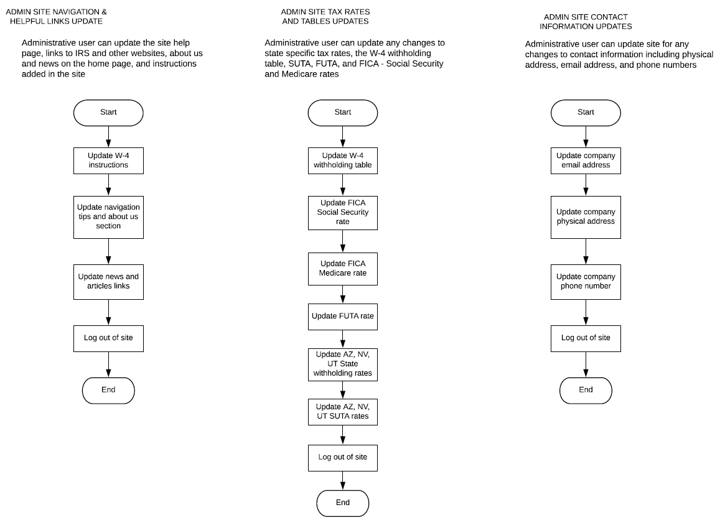

**Calculation Values/Application Page:** This is where the user will fill out the information needed to generate the payroll tax calculations. They will update residency and location information, and input the salary, and number of allowances claimed if they are logged in as a member. For the salary portion, the user will amount of salary paid, and how long they worked in each location (if applicable). Guest users will be required to enter all pertinent information before computation takes place.

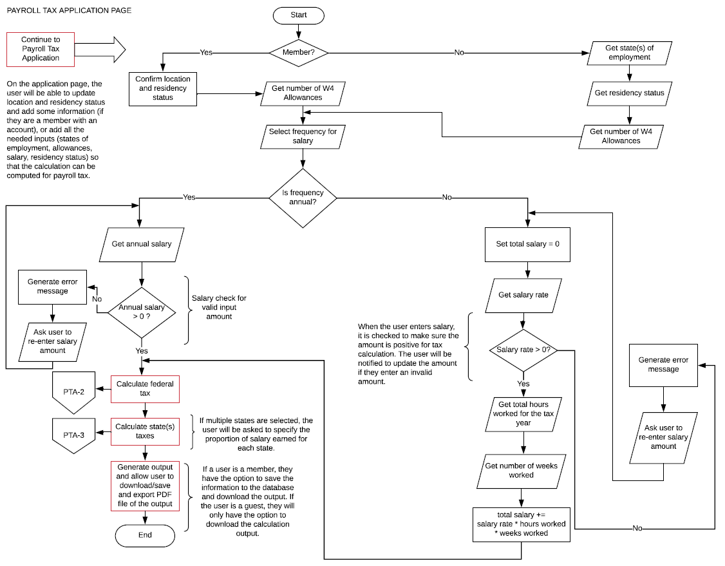

Two off-page connectors for the detailed federal and state tax deductions and withholdings calculations can be seen in the next two pages.

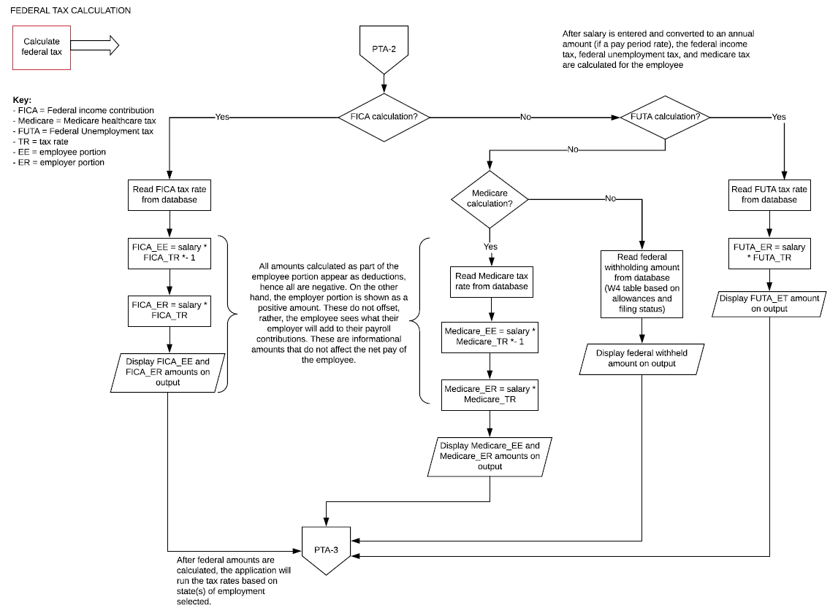

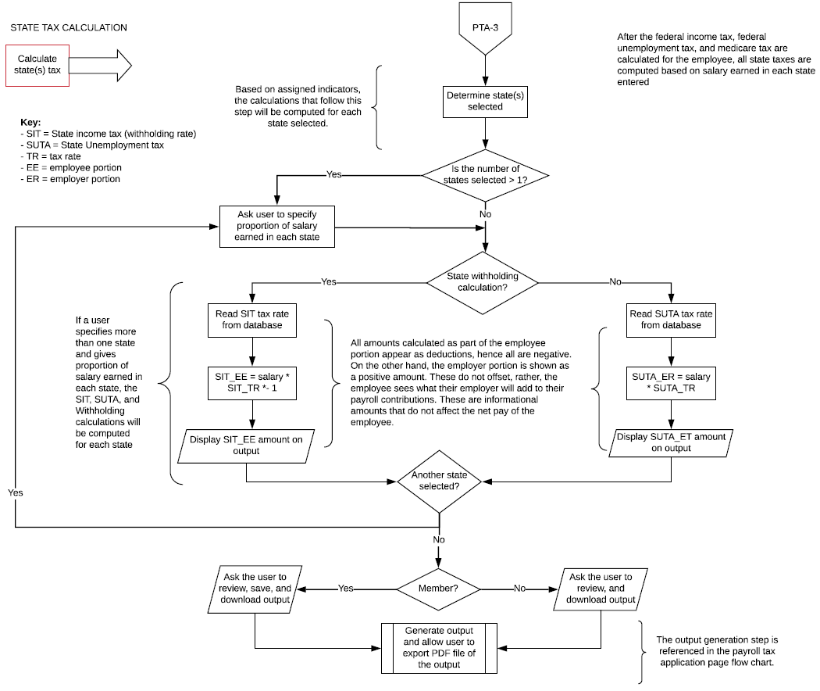

**Review Page:** Once all calculations shown above have taken place, the user will be able to review all the information and click continue. Once the calculation is completed, the user can export the result to PDF. As mentioned earlier in the interface portion, member users will also be able to save the data in their profile and therefore to the database. The exported product will have the categories and calculations to explain what they stand for and a breakdown of the salary, all the deductions and contributions from employer, and the net pay/take home amount. The highlighted portion of the flow chart above demonstrates the download options for the different user types. At this type, our exported product is of low quality, so we also encourage the user to take a screenshot of the review page for their records.

**Project Fulfilment Estimation:**

We plan to design this application using different components of C# to fulfill the requirements and scope we defined earlier. These are broken down in seven categories below:

1. **Variables and Constants**

We are considering different variables and constants in order to move our project ahead and create the application. We used variables and constants to define a lot of the user interface messages for the user, and variables to pass along forms during tax calculation functions. Other fixed rates and numbers that are already defined by tax law and are available on the IRS website. As mentioned in the form section, additional resources to verify these rates have been provided in the completed folder. We saved these in the database, and define the variables as we get them from the database table.

1. **Decision Structure and Iteration Structure**

We hope to use multiple decision structure formats for any of the available calculation options (if… else, while and for loops). An example of a decision structure to check for whether states have been selected while compiling totals has been defined below for the review page:

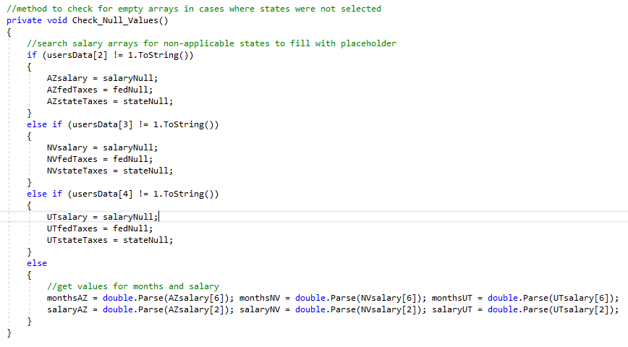

1. **Methods**

In order to have a successful application which is capable of handling different assigned tasks, we used a number of methods for calculation functions. For example, as an extension from the decision structure example above, we used this method before each calculation to ensure that all arrays were filled and that we wouldn’t get compiling null value errors during computation.

1. **Arrays**

For some of the tax category calculations, we needed to read large tables of information to get tax deductions. For example, for the federal tax withholding amount, we saved the IRS W-4 bi-weekly and annual tables up to our USD 100,000 limit, and extract the values in an arrays to use them in the calculation methods for federal taxes by reading the deduction amount based on W-4 number of allowances, salary, and marital status. For reference, this table and the annual one are available in the supplemental document ***Publication 15 2017***.

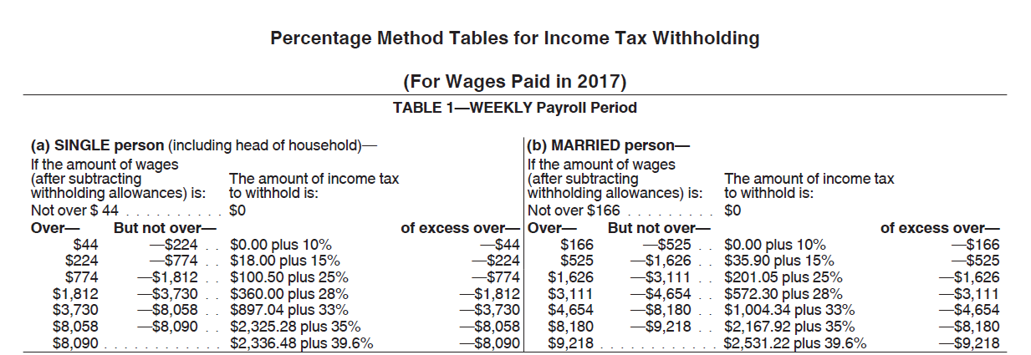

1. **Multiple Forms**

We have different forms for calculations, log in, and administrator functions. We have up to five forms that the user sees depending on whether they are a returning user or signing up, as well as different export pages for the two. We also have over twice that in admin forms for administrative updates. These include updating the help and information, and tax rates, managing feedback, and updating the home page in the database.

1. **Database CRUD**

We used the create operation when a user signs up and whenever they click the save option in the payroll detail page (for a member). We will read details about user from the user table and then show it on the output detail page. Additionally, there will be an option to update or edit the user detail, and profile users’ information is saved in the salary table (tblSalary). The fields and the details mentioned here are referenced in the file and database design section. If the admin user has reviewed feedback, they can delete the record and manage that table.

1. **File access**

We read text files to show the information in the *Help and Information* page, the *Home* page, and *Contact Us* page. Additionally, when a user downloads their payroll detail, it will be saved as a PDF file image. This export is of low quality, and is a limitation that we would hope to improve given chance for enhancements.